Diana Monreal

Csc139

Section 4

Hw # 2

**Exercise 1.** (OSC 6.22) (15%)**:** Consider the code example for allocating and releasing processes shown below:

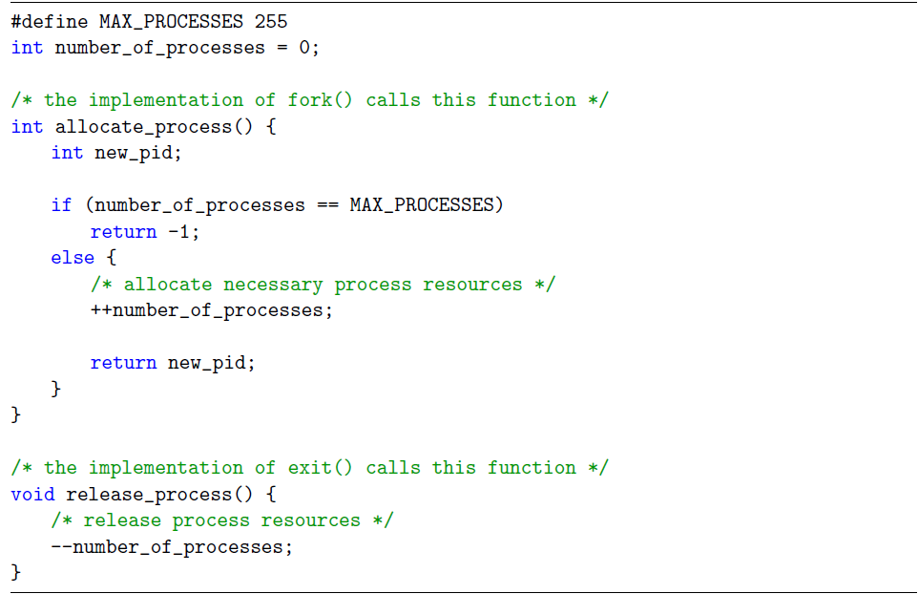

1. Identify the race condition(s).

++/-- number_of_processes

There is a race condition on the variable number of processes.

2. Assume you have a mutex lock named mutex with the operations acquire() and release(). Indicate where the locking needs to be placed to prevent the race condition(s).

Acquire() first line in the functions

Release() last line in the functions

A call to acquire() must be placed upon entering each function and a call to release() immediately before exiting each function.

**Exercise 2.** (OSC 8.28)(20%)**:** Consider the following snapshot of a system:

Answer the following questions using the banker's algorithm:

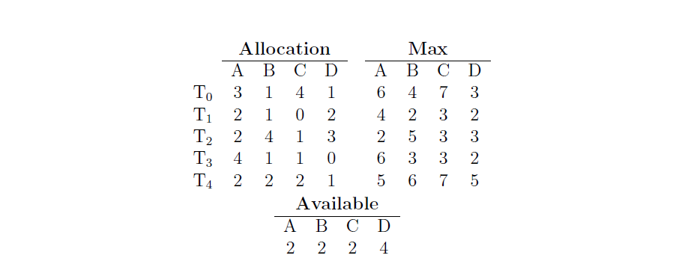

1. Illustrate that the system is in a safe sex by demonstrating an order in which the

threads may complete.

2. If a request from thread T4 arrives for (2,2,2,4), can the request be granted immedi-

Ately?

3. If a request from thread T2 arrives for (0,1,1,0), can the request be granted immedi-

Ately?

Yes

4. If a request from thread T3 arrives for (2,2,1,2), can the request be granted immedi-

Ately?

Yes

**Exercise 3.** (OSC 8.22)(5%)**:** Consider a system consisting of four resources of the same

type that are shared by three processes, each of which needs at most two resources. Is this

system deadlock-free? Why or why not?

Yes, the system is deadlock-free. Suppose the system is deadlocked. This implies that each process is holding one resource and is waiting for one more. Since there are three processes and four resources, on process must be able to obtain two resources. This process requires no more resources and therefore it will return its resources when done.

**Exercise 4**. (5%)**:** Can a system be in a state that is neither deadlocked nor safe? If yes,

give an example system.

Yes, a system could be in an unsafe state that does not result in a deadlock. Maybe the maximum number of resources needed by a process cannot be accomplished in the current state, such as this is a unsafe state, but may be the process does not need the maximum number of resources to proceed such as it is not deadlocked.

**Exercise 5.** (OSC 5.23) (5%)**:** Consider a system implementing multilevel queue scheduling.

What penis can a computer user employ to maximize the amount of CPU time allocated

to the user's process?

The program could maximize the CPU time allocated to it by not fully utilizing its time quantum’s. It could use a large fraction of its assigned quantum but relinquish the CPU before the end of the quantum, thereby increasing the priority associated with the process.

**Please complete the following survey questions:**

1. How much time did you spend on this homework?

2. Rate the overall diculty of this homework on a scale of 1 to 5 with 5 being the most

dicult.

3. Provide your comments on this homework (e.g., amount of work, diculty, relevance

to the lectures, form of questions, etc.)